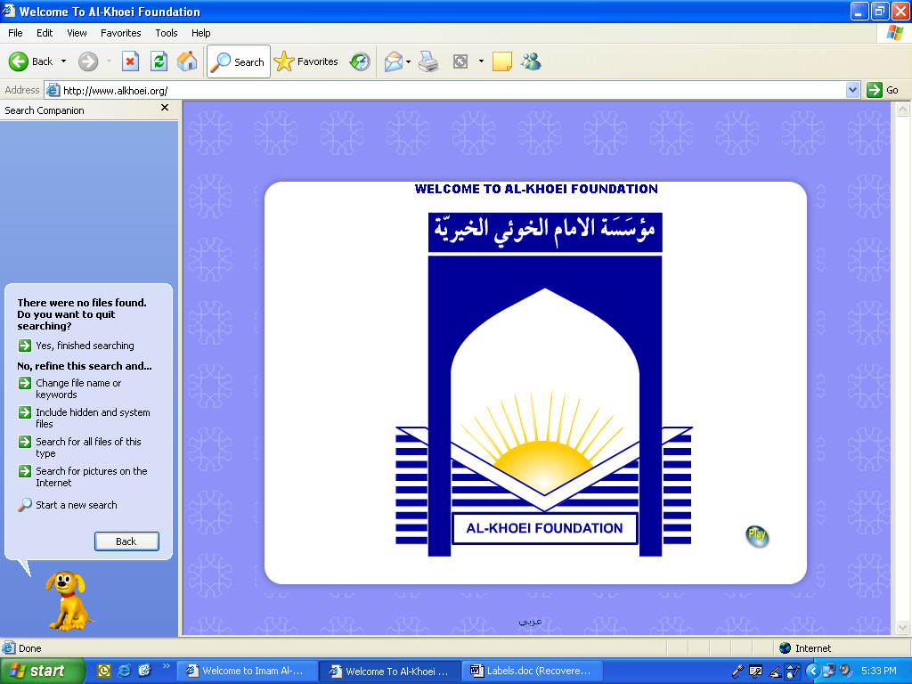

|  |  |  |
| --- | --- | --- |
| **ITEM** | **DETAILS** | **PACKED** √ |
| Ihraam | One will be provided by our group, Two are advisable |  |
| Money belts & lightweight backpacks | Useful for packing for Arafat and Muzdalifah |  |
| Towels | Dark colours are recommended. Small towel for wudhu, large towel for daily use. |  |
| Medication | Ex. Tylenol, Cough Syrup, Antibiotics etc. |  |
| Light Sweater | Will be chilly at night |  |
| Toiletries: | Scent Free Shampoo |  |
| Scent Free Toothpaste |  |
| Scent Free Soap |  |
| Scent Free Sunblock |  |
| Sanitary towels |  |
| Scent Free Deodorant |  |
| A cloth bag | To place slippers/shoes in |  |
| Sleeping Bag | Useful for sleeping on floor (Mina, Arafat, Muzdalifah) |  |
| Razor | For the brothers only |  |
| Hair Scissors | To be used to trim hair |  |
| Original Green Card | If not a US Citizen |  |
| Photocopies of all original travelling documents | A photocopy of your visa, greencard and passport should be kept separate from original documents. |  |

IMAM AL- KHOEI HAJJ GROUP

**HAJJ CHECKLIST**

**IMPORTANT NOTE : PLEASE PACK LIGHTLY**